**Remember to suggest these i-Ready Apps for parents**

Apps for Targeted Skill and Practice

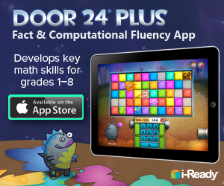i-Ready’s reading and mathematics apps complement i-Ready’s student and teacher-led instruction. These educational games provide targeted skill development in areas shown to hold students back, help educators ensure long-term achievement gains, and increase student performance and growth outcomes.

Door 24® Plus

Door 24 Plus sends students on a mathematical adventure! Students will take a quick assessment and then head into either Snargg Splatt to work on fact fluency or Victor Fixer to work on computational fluency.

Game scenario: Our pesky, blue-hued friend Snargg has escaped once again only to discover a mystical door hidden behind the fridge in the BakeStars Café! Join Sweet T and friends as they explore the mysteries behind Door 24.

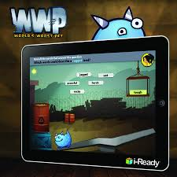World's Worst Pet®

Tier Two Vocabulary App

The BakeStars' new pet is out of this world…literally! After adopting this creature from outer space, the BakeStars find out it has a taste for danger and loves to get into all kinds of trouble. Even though it may be the world’s worst pet—Jake and friends still need help to keep it safe!

Instructional Objectives

* Delivers multiple exposures and robust practice
* Supports the development of comprehension

Focus on Tier Two Vocabulary

* Academic vocabulary that appears across a wide range of texts
* Domain-specific vocabulary: Science and Social Studies